Impact of 5G NR-V2X Mode 2 Message Losses on Cooperative Vehicle Behavior: A Reproducible Co-Simulation Study with Ray-Tracing-in-the-Loop
Andrey V. Fizulin
Moscow Institute of Electronics and Mathematics (MIEM)
HSE University, Moscow, Russia
avfizulin@edu.hse.ru

Abstract—Connected and automated vehicles rely on timely V2X message exchange for cooperative safety functions, yet the quantitative link between 5G NR sidelink Mode 2 radio-layer degradation and application-level behavioral outcomes remains insufficiently explored. We present a reproducible co-simulation framework coupling SUMO, ns-3 with NR-V2X, and NVIDIA Sionna RT ray-tracing, augmented with an ID-aware packet tracing mechanism and an automated causal audit pipeline. Two deterministic scenarios are evaluated: an Emergency Vehicle Alert with parametric transmit-power variation, and a lane-change-upon-leader-stop scenario with per-vehicle link-quality degradation. Results show that reducing the packet reception ratio from 0.94 to 0.08 increases the 90th-percentile cooperative reaction delay from 4.0 s to 18.1 s, delays first braking by up to 5 s, and, in the lane-change scenario, the causal audit confirms a complete chain from packet loss through delayed decision to collision. These findings quantify the sensitivity of cooperative driving functions to sidelink quality and support a digital-twin methodology for tracing communication failures through to safety-critical traffic outcomes.
Keywords—V2X, NR-V2X Mode 2, co-simulation, digital twin, packet reception ratio, cooperative driving, ray-tracing, SUMO, ns-3, Sionna RT, causal audit.

Introduction
Connected and automated vehicles (CAVs) introduce fundamentally new requirements for the quality of telecommunications infrastructure. Cooperative perception, hazard warning, and maneuver coordination depend on timely exchange of V2X (Vehicle-to-Everything) messages, and any disruptions in the communication channel directly affect driving safety [1], [2], [3]. In the European ITS architecture, Cooperative Awareness Messages (CAMs) provide periodic kinematic state updates [4], while Decentralized Environmental Notification Messages (DENMs) deliver event-driven alerts [5].
Traditional approaches to V2X quality assessment rely on aggregate network metrics—mean packet reception ratio (PRR) and average latency—without establishing a formal link between network events and observed traffic outcomes [6], [7]. Consequently, the assessment of how message losses affect cooperative driving safety remains fragmented: network metrics are analyzed in isolation from behavioral metrics, and the causal chain ‘message loss → changed agent decision → traffic outcome’ is neither formalized nor experimentally verified.
For 5G NR-V2X sidelink in autonomous resource allocation mode (Mode 2), the loss structure is particularly complex. Beyond external radio interference, losses arise from distributed access collisions, hidden nodes, resource selection window parameters, and application traffic load [8]. The 3GPP evaluation methodology TR 37.885 defines PRR as a baseline reliability metric for V2X scenarios [8]. However, aggregate PRR alone does not capture the temporal structure of losses or the freshness of delivered information, and is therefore insufficient for explaining application-level behavioral transitions [9], yet equal PRR values may correspond to fundamentally different internal loss structures—rendering PRR necessary but insufficient for explaining application-level behavioral transitions [7], [8].
Existing simulation environments for CAVs often decouple communication quality assessment from behavioral modeling. While frameworks like Veins [10], Eclipse MOSAIC [11], and ms-van3t [12] provide varying degrees of integration, the link between channel degradation and safety-critical traffic outcomes through intermediate metrics (packet inter-reception interval, age of information) is rarely traced end-to-end. Ray-tracing-in-the-loop approaches, such as VaN3Twin [13], strengthen the geometric fidelity of channel modeling but do not inherently provide the causal traceability from individual packet losses to behavioral decisions.
Bridging this gap requires a digital-twin co-simulation methodology that embeds data-driven causal analysis directly into the evaluation loop of intelligent networked cyber-physical systems (CPS). Such a methodology aligns with the growing recognition that application-aware network assessment—where the network is evaluated not by aggregate KPIs but by its downstream impact on autonomous agent behavior—is increasingly recognized as important for the design and assessment of cooperative driving functions [2].
This paper makes the following contributions: (1) a reproducible co-simulation framework integrating SUMO, ns-3 with NR-V2X Mode 2, and NVIDIA Sionna RT ray-tracing, with an ID-aware packet tracing mechanism that achieves strict match ratio = 1.0; (2) an automated causal audit pipeline linking packet drops to application-level decisions and traffic outcomes; (3) two deterministic experimental scenarios quantifying the nonlinear relationship between PRR degradation and cooperative reaction delay, braking time, and collision occurrence; and (4) an experimental demonstration that the 90th-percentile reaction delay increases from 3.98 s to 18.09 s as PRR degrades from 0.94 to 0.077.

Related Work
The influence of communication quality on CAV behavior has been studied along several axes. Viriyasitavat et al. [6] survey channel and propagation models for vehicular communications, emphasizing the strong dependence of reliability on the environment and chosen model. Boban et al. [14] propose GEMV², a geometry-based V2V channel model for large-scale simulation that distinguishes line-of-sight, vehicle-obstructed, and building-obstructed conditions. The impact of vehicles as obstacles on V2V communication is further analyzed in [15].
For NR-V2X sidelink, Harounabadi et al. [8] review Mode 2 resource allocation in Release 16 and beyond, highlighting distributed scheduling challenges. Romanov and Stepanyants [2] survey integrated simulation environments for CAVs, identifying requirements for reproducibility, tool composition, and architecture. The ms-van3t framework [12] provides a multi-stack V2X validation environment atop ns-3, while VaN3Twin [13] extends it with Sionna RT ray-tracing-in-the-loop.
Surrogate safety assessment using TTC and PET is well-established [16], and the role of Age of Information (AoI) as a bridge metric between network events and controller state has been formalized in [7], [17]. However, prior works typically evaluate network metrics and behavioral metrics separately. To the best of our knowledge, no prior study provides end-to-end causal tracing from individual 5G NR-V2X Mode 2 packet drops through application-level decisions to collision outcomes within a reproducible digital-twin framework with ray-tracing.

Co-Simulation Framework

Architecture Overview
The proposed framework implements a bidirectional cyber-physical simulation loop comprising four layers: (1) the application layer (emergencyVehicleAlert), (2) the ETSI Facilities Layer (CA Basic Service, DEN Basic Service, CP Basic Service [18]), (3) the network/transport layer (BTP, GeoNetworking, DCC), and (4) the channel/physical layer supporting IEEE 802.11p, LTE-V2X Mode 4, and NR-V2X Mode 2, with optional Sionna RT ray-tracing. The traffic simulator SUMO communicates with ns-3 via the TraCI interface [20], synchronizing vehicle positions, speeds, and control actions at each simulation step.
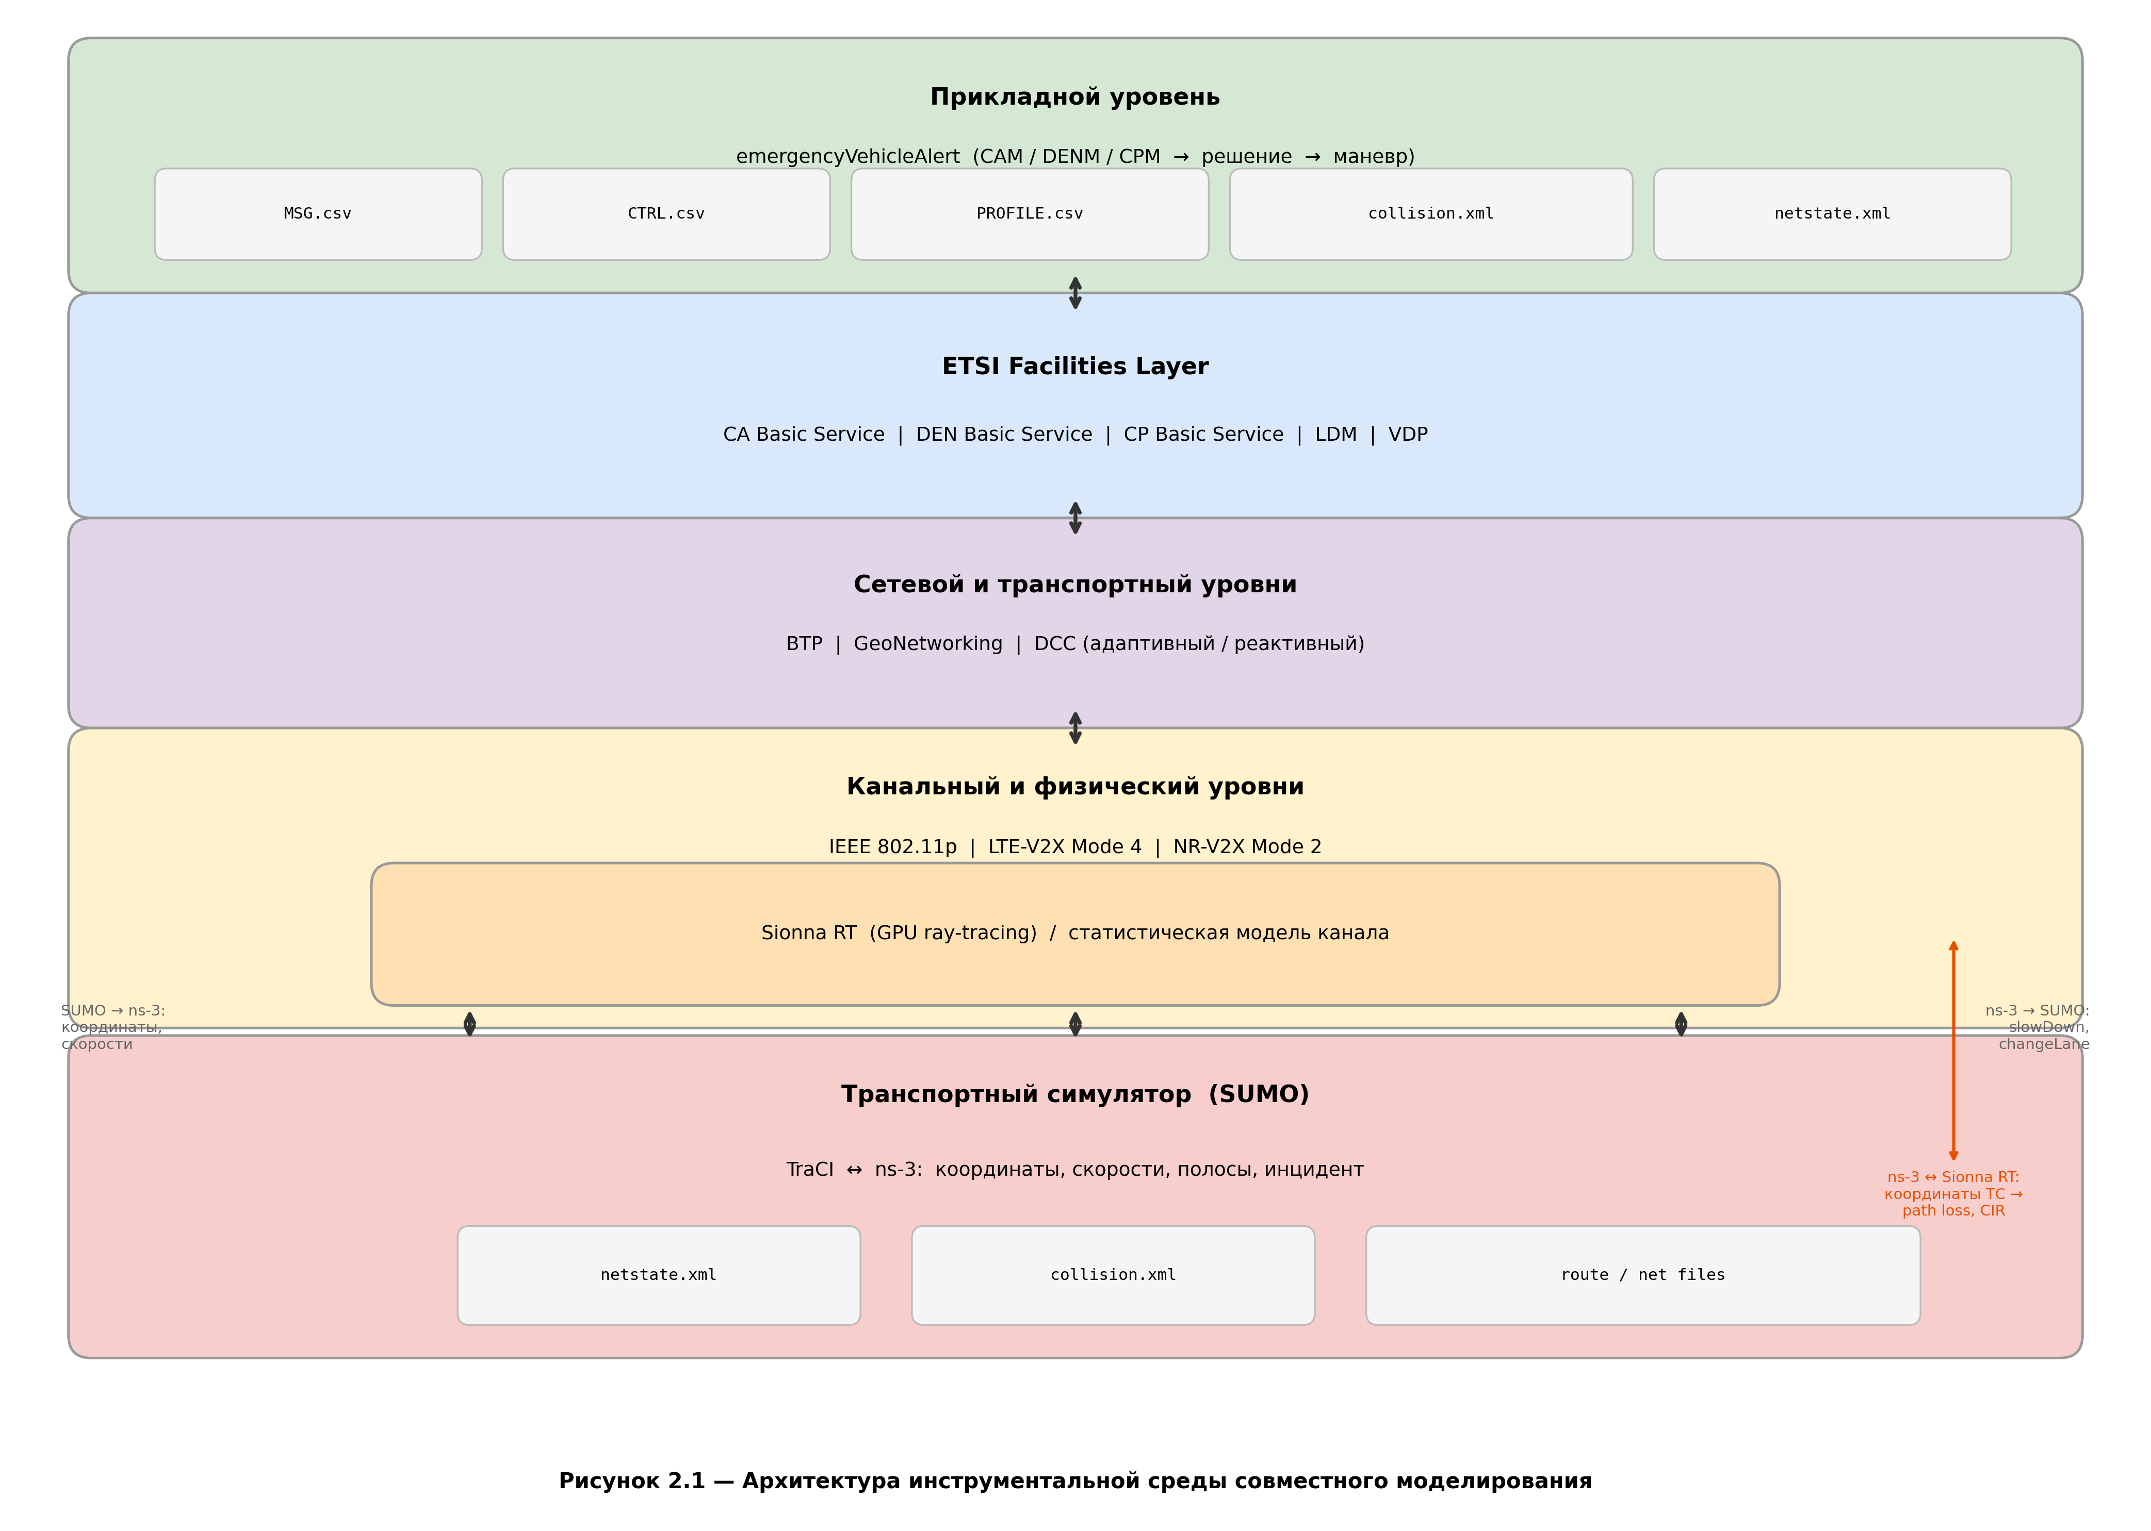
- Fig. 1. Architecture of the co-simulation framework. Arrows denote data flow between SUMO (traffic), ns-3 (network), Sionna RT (channel), and the causal audit pipeline.
Sionna RT [19] is used as the ray-tracing engine. In our implementation, it is deployed as an external GPU service that accepts UDP requests for channel-parameter computation from 3D transmitter and receiver positions. At each ns-3 step, the module submits vehicle coordinates; Sionna performs ray-tracing accounting for scene geometry and returns channel parameters (path loss, Doppler shift). This design follows the VaN3Twin ray-tracing-in-the-loop paradigm [13] while extending it with per-vehicle link-quality profiles and causal tracing. The resulting digital-twin loop enables application-aware network assessment: the same simulation instance that computes PHY-layer metrics also drives the traffic agents whose safety outcomes are the ultimate evaluation criterion.

Per-Vehicle Link-Quality Profiles
A key extension is the per-vehicle-prr-profile mechanism, which assigns each vehicle individual radio parameters: PHY-layer CAM drop probability, equivalent transmit power, and target PRR. Profiles are specified as command-line parameters in the format veh3:0.05:23:0.95,veh4:0.923:−20:0.077. This enables controlled, reproducible degradation of specific links while maintaining identical traffic scenarios, initial conditions, and random number generator states.

ID-Aware Packet Tracing
Each transmitted CAM is assigned a unique packet identifier (pkt_uid) preserved across all lifecycle stages: transmission (TX), successful reception (RX), PHY-layer drop (DROP_PHY), and application-level decision (CTRL). The tracing system generates per-vehicle log files: MSG.csv (message events), CTRL.csv (control decisions), and PROFILE.csv (link-quality configuration). A post-processing script correlates DROP events with DECISION events by pkt_uid, constructing a timeline that maps each lost packet to its corresponding application-level consequence. The achieved strict match ratio = 1.0 confirms that every packet loss has a traceable application-level outcome.

Automated Causal Audit
The causal audit pipeline reconstructs the chain ‘packet loss → no-action decision → collision’ for each crash event. The audit script identifies collision participants from SUMO’s collision.xml, analyzes the event window preceding the collision timestamp, counts drop events and no-action decisions within that window, and classifies the causal strength as strong_no_action_only, mixed, or weak. This automated, data-driven procedure replaces manual log inspection and provides a structured, reproducible evidence chain for attributing safety outcomes to communication failures.

Experimental Design

Scenario 1: Emergency Vehicle Alert with Parametric TX Power Sweep
The first scenario is based on the v2v-emergencyVehicleAlert-nrv2x example from the open-source ms-van3t framework [12]. In NR-V2X Mode 2 sidelink configuration, vehicles exchange CAMs [4] using autonomous resource allocation [8], [22]. A parametric sweep varies only the transmit power (txPower) across iterations while fixing trajectories, parameters, and random number generator seeds. The communication metric is PRR, defined as the fraction of successful receptions among potential receivers [9]. The reaction metric is the time to first CAM reception from the emergency vehicle (stationId = 2) for each participant, from which median and 90th-percentile statistics are computed. Additionally, SUMO data provide the median time to first braking.

Scenario 2: Lane-Change upon Leader Stop with Causal Audit
The second scenario models a sequence of vehicles in the right lane, where the leading vehicle stops, becoming a stationary obstacle. The experimental hypothesis states that if following vehicles receive timely V2X warnings, they perform lane changes and maintain safe traffic flow; if one vehicle’s link quality degrades sharply, its decision is delayed and the conflict results in a collision.
Two contrasting regimes are defined. In the safe regime, all vehicles maintain high link quality: veh3 (equiv_tx_power = 23 dBm, PRR = 0.945), veh4 (23 dBm, PRR = 0.944), veh5 (0 dBm, PRR = 0.722). In the crash regime, degradation is introduced only for veh4: equiv_tx_power = −20 dBm, PRR = 0.071, while veh3 and veh5 retain identical parameters. The traffic scenario, incident time (t = 6.00 s), and fleet composition remain constant; only the critical vehicle’s link quality changes.

Reproducibility Provisions
All experiments follow a strict reproducibility protocol [2]: road geometry and route files are versioned; SUMO microscopic model parameters are fixed; network parameters, link-quality profiles, Sionna RT settings, and random number generator states are locked. For each scenario, not only final plots but also raw CSV logs are produced as auditable artifacts. The entire experiment is executable via a single shell command.

Results
The results presented below are drawn from a proof-oriented deterministic study rather than a full statistical campaign. Each experimental point corresponds to a single controlled run with fixed seeds, enabling exact causal attribution at the cost of statistical generalizability. We consider this an appropriate trade-off for demonstrating the methodology and establishing the causal chain; multi-seed campaigns with confidence intervals are deferred to future work (Section VII).

PRR vs. Transmit Power
Fig. 2 shows the monotonic increase of PRR with txPower in NR-V2X Mode 2. At txPower = −20 dBm, PRR drops to approximately 0.077, while at txPower = 23 dBm it reaches 0.94. The relationship is nonlinear, with a sharp transition in the range [−10, 0] dBm.
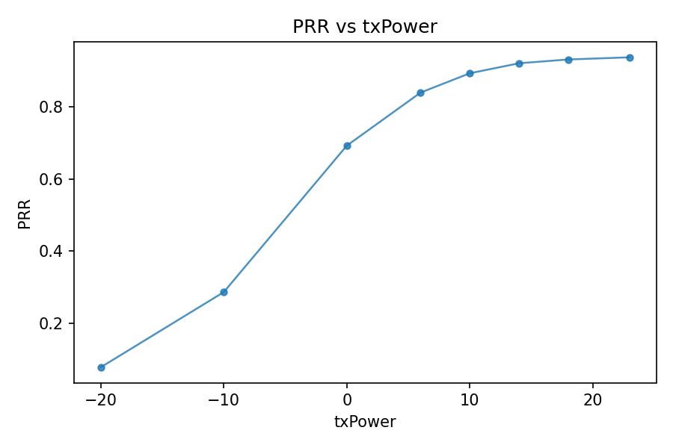
- Fig. 2. PRR vs. txPower (NR-V2X Mode 2). Monotonic increase with sharp transition around −10 to 0 dBm.

Cooperative Reaction Delay
Fig. 3 presents the 90th-percentile cooperative reaction delay as a function of PRR. At PRR ≈ 0.94, the 90th-percentile delay is 3.98 s; at PRR ≈ 0.077, it rises to 18.09 s—a factor of 4.5×. The relationship is strongly nonlinear: moderate PRR degradation (0.94 → 0.6) increases the delay by approximately 2 s, whereas degradation below 0.3 causes the delay to escalate sharply. This nonlinearity implies that system designers cannot rely on linear interpolation of delay bounds from PRR measurements.
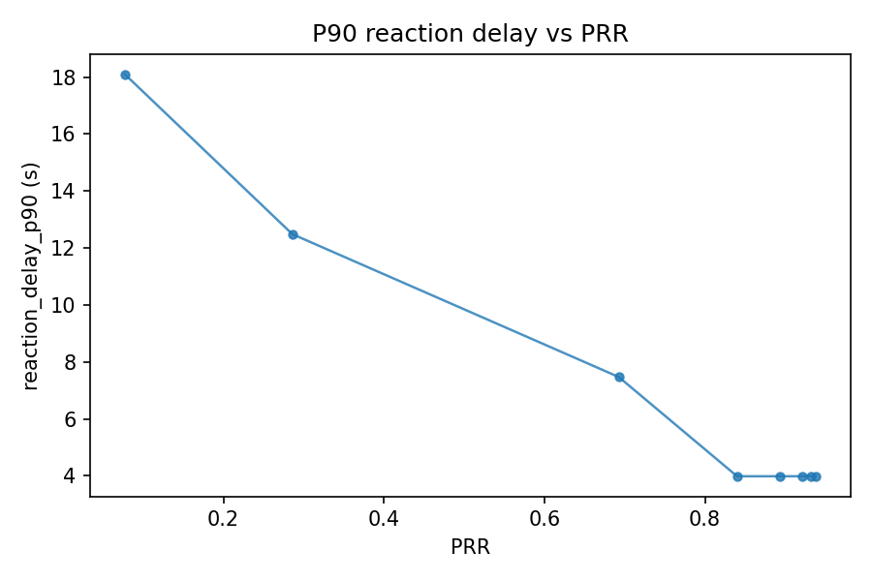
- Fig. 3. 90th-percentile cooperative reaction delay vs. PRR. Nonlinear escalation below PRR = 0.3.

Time to First Braking
Fig. 4 shows the median time to first braking as a function of PRR. The trend is consistent with the reaction delay: at high PRR, braking initiates near t ≈ 6 s (shortly after the incident), whereas at PRR ≈ 0.077, the median braking onset shifts to t ≈ 11 s. The 5-second delay in braking onset represents a substantial safety degradation, particularly at highway speeds where each second of delayed braking corresponds to approximately 25–33 m of additional travel.
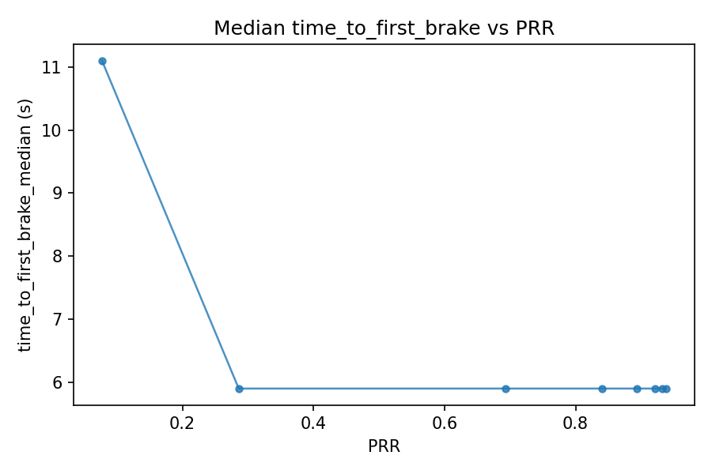
- Fig. 4. Median time to first braking vs. PRR. Delayed braking at low PRR extends stopping distance.

Safe vs. Crash Regime: Causal Analysis
In Scenario 2, the safe regime produces an orderly cascade of lane changes: veh3 at t = 7.14 s, veh4 at t = 9.13 s, veh5 at t = 12.13 s, with zero collisions in collision.xml. In the crash regime, veh3 still changes lane successfully (high PRR), but veh4 (PRR = 0.071) fails to receive the emergency CAM in time. The causal audit confirms a strong_no_action_only classification: every dropped CAM maps to a no-action decision on the application layer, and the accumulation of no-action decisions directly precedes the collision event.
Table I summarizes the key timing differences between the two regimes. The critical observation is that the traffic scenario is identical in both cases—the only variable is veh4’s equivalent transmit power, which controls its PRR. This isolation of the communication variable, combined with the pkt_uid-based causal audit, provides strong evidence that the collision outcome is causally attributable to V2X link degradation.
- TABLE I. Timing comparison: safe vs. crash regime (Scenario 2)
Metric | Safe Regime | Crash Regime
veh3 first lane change | 7.14 s | 7.14 s
veh4 first lane change | 9.13 s | No lane change
veh5 first lane change | 12.13 s | 12.13 s
Collision | None | veh4 rear-ends veh2
Causal classification | N/A | strong_no_action_only

Cross-Technology Comparison
Table II provides a comparative snapshot of IEEE 802.11p and NR-V2X Mode 2 under identical co-existence conditions (10 nodes, standard parameters) [23]. NR-V2X achieves a higher mean PRR (0.962 vs. 0.920) but at the cost of substantially higher latency (12.3 ms vs. 0.49 ms). For safety-critical cooperative functions, this latency–reliability trade-off must be evaluated in the context of application-level timing budgets rather than aggregate network metrics alone. The values in Table II are configuration-specific and reflect the considered co-existence setup and parameterization rather than a universal ranking of the two radio technologies; different parameterizations or traffic loads may yield different results.
- TABLE II. Comparison of radio technologies (10 nodes, co-existence)
Metric | IEEE 802.11p | NR-V2X Mode 2
Mean PRR | 0.920 | 0.962
PRR range | 0.789 – 1.000 | 0.826 – 1.000
Mean latency | 0.49 ms | 12.3 ms
Latency range | 0.44 – 0.64 ms | 7.7 – 16.8 ms

Discussion
The experimental results reveal several insights of practical importance. First, the nonlinear sensitivity of cooperative reaction delay to PRR degradation implies that performance guarantees based on mean PRR are misleading. The 90th-percentile delay—representing the worst-case participants—escalates much faster than the mean, particularly below PRR = 0.3. System designers must therefore specify communication requirements in terms of tail percentile bounds on reaction delay, not average PRR.
Second, the causal audit methodology provides a principled mechanism for attributing safety outcomes to communication failures. The strict match ratio = 1.0 between DROP_PHY events and application-level decisions indicates that, in the considered scenarios, every packet loss has a traceable application-level outcome. The classification of causal strength (strong, mixed, weak) enables automated prioritization of failure modes in large-scale simulation campaigns.
Third, the per-vehicle link-quality profile mechanism enables fine-grained controlled experiments in which only the communication variable changes while the traffic scenario remains identical. This is important for isolating causal effects and distinguishes our approach from studies that vary traffic and communication parameters simultaneously.
Fourth, the integration of Sionna RT ray-tracing provides geometry-sensitive channel modeling, capturing effects of buildings, vehicle obstructions, and scene geometry that stochastic models may average out. For intersection scenarios where line-of-sight transitions are abrupt, this level of fidelity is important for realistic assessment of V2X reliability.
From a broader perspective, the framework instantiates a digital-twin approach to intelligent networked CPS evaluation: the co-simulation loop reproduces the full cyber-physical interaction between communication, perception, decision-making, and vehicle dynamics, while the automated causal audit provides a data-driven analytical layer that converts raw simulation logs into structured safety evidence. This combination offers a basis for systematic assessment of cooperative driving systems, where reproducible, end-to-end causal traceability is highly desirable.

Limitations and Future Work
Several limitations apply. The presented results are derived from single-seed deterministic runs; while this design maximizes causal clarity, it does not yield confidence intervals or distributional statistics. A multi-seed statistical campaign covering varying traffic densities, radio parameters, and random access contention levels is required to generalize the quantitative findings.
The vehicle control logic is not closed-loop with respect to network metrics: trajectory modifications and maneuver stability under varying feedback quality are not examined. The analysis focuses on the reaction to the first successfully received CAM and derived percentile statistics.
The per-vehicle-prr-profile mechanism, while enabling controlled degradation, applies a simplified loss model (independent drops). In NR-V2X Mode 2, burst losses due to persistent half-duplex collisions are structurally different from independent losses [8]. Future work will integrate burst-aware loss patterns derived from MAC-layer traces.
Planned extensions include: (1) expanding the causal audit to incorporate PIR and AoI as intermediate causal variables; (2) evaluating additional cooperative functions (platooning [24], cooperative intersection management); (3) conducting multi-seed statistical campaigns with confidence intervals; and (4) validating simulation results against field measurements from V2X testbeds.

Conclusion
We presented a reproducible co-simulation framework for quantifying the impact of 5G NR-V2X Mode 2 message losses on cooperative vehicle behavior. The framework couples SUMO, ns-3, and Sionna RT ray-tracing with an ID-aware packet tracing mechanism achieving strict match ratio = 1.0 and an automated causal audit pipeline.
Experiments on two deterministic scenarios show that: (1) PRR degradation from 0.94 to 0.077 increases the 90th-percentile cooperative reaction delay from 3.98 s to 18.09 s, exhibiting strongly nonlinear sensitivity; (2) median braking onset is delayed by up to 5 s under severe link degradation; (3) the causal audit confirms a ‘packet loss → no-action → collision’ chain with strong causal classification in the crash regime; (4) NR-V2X Mode 2 offers higher PRR than IEEE 802.11p but at higher latency, requiring application-specific evaluation.
These results indicate that cooperative safety functions are sensitive to communication channel quality in ways that aggregate metrics can obscure, and that reproducible co-simulation with end-to-end causal tracing provides a robust basis for reliable V2X system assessment. The framework source code, scenario configurations, and analysis scripts will be made available upon publication.

Acknowledgment
This work was conducted at the CAD Systems Laboratory, Department of Computer Engineering, Moscow Institute of Electronics and Mathematics (MIEM), HSE University.

References
- SAE International, “Taxonomy and Definitions for Terms Related to Driving Automation Systems for On-Road Motor Vehicles,” SAE J3016, Rev. Apr. 2021, doi: 10.4271/J3016_202104.
- V. G. Stepanyants and A. Yu. Romanov, “A survey of integrated simulation environments for connected automated vehicles: Requirements, tools, and architecture,” IEEE Intell. Transp. Syst. Mag., vol. 16, no. 2, pp. 6–22, 2024, doi: 10.1109/MITS.2023.3335126.
- NHTSA, “Vehicle-to-Vehicle Communication: Readiness of V2V Technology for Application,” DOT HS 812 014, 2014.
- ETSI EN 302 637-2 V1.4.1, “Intelligent Transport Systems (ITS); Vehicular Communications; Basic Set of Applications; Part 2: Specification of Cooperative Awareness Basic Service,” 2019.
- ETSI EN 302 637-3 V1.3.1, “Intelligent Transport Systems (ITS); Vehicular Communications; Basic Set of Applications; Part 3: Specification of Decentralized Environmental Notification Basic Service,” 2019.
- W. Viriyasitavat, M. Boban, H.-M. Tsai, and A. Vasilakos, “Vehicular communications: Survey and challenges of channel and propagation models,” IEEE Veh. Technol. Mag., vol. 10, no. 2, pp. 55–66, Jun. 2015, doi: 10.1109/MVT.2015.2410341.
- M. A. Abd-Elmagid, N. Pappas, and H. S. Dhillon, “On the role of age of information in the Internet of Things,” IEEE Commun. Mag., vol. 57, no. 12, pp. 72–77, Dec. 2019, doi: 10.1109/MCOM.001.1900041.
- M. Harounabadi et al., “V2X in 3GPP standardization: NR sidelink in Rel-16 and beyond,” IEEE Commun. Standards Mag., vol. 5, no. 1, pp. 12–21, 2021, doi: 10.1109/MCOMSTD.001.2000070.
- 3GPP TR 37.885, “Study on evaluation methodology of new V2X use cases for LTE and NR,” v15.3.0, 2019.
- C. Sommer, R. German, and F. Dressler, “Bidirectionally Coupled Network and Road Traffic Simulation for Improved IVC Analysis,” IEEE Trans. Mobile Comput., vol. 10, no. 1, pp. 3–15, Jan. 2011, doi: 10.1109/TMC.2010.133.
- Eclipse MOSAIC, “Multi-Domain and Multi-Scale Simulation for Connected and Automated Mobility,” [Online]. Available: https://eclipse.dev/mosaic/
- DriveX-devs, “ms-van3t: Multi-stack vehicular network simulation framework,” [Online]. Available: https://github.com/DriveX-devs/ms-van3t
- DriveX-devs, “VaN3Twin: Vehicular digital twin framework with ray-tracing-in-the-loop,” [Online]. Available: https://github.com/DriveX-devs/VaN3Twin
- M. Boban, J. Barros, and O. K. Tonguz, “Geometry-based vehicle-to-vehicle channel modeling for large-scale simulation,” IEEE Trans. Veh. Technol., vol. 63, no. 9, pp. 4146–4164, Nov. 2014, doi: 10.1109/TVT.2014.2317803.
- M. Boban, T. T. V. Vinhoza, M. Ferreira, J. Barros, and O. K. Tonguz, “Impact of vehicles as obstacles in vehicular ad hoc networks,” IEEE J. Sel. Areas Commun., vol. 29, no. 1, pp. 15–28, Jan. 2011, doi: 10.1109/JSAC.2011.110103
- FHWA, “Surrogate Safety Assessment Model and Validation: Final Report,” FHWA-HRT-08-051, 2008.
- Y. Sun, E. Uysal-Biyikoglu, R. D. Yates, C. E. Koksal, and N. B. Shroff, “Update or wait: How to keep your data fresh,” IEEE Trans. Inf. Theory, vol. 63, no. 11, pp. 7492–7508, Nov. 2017, doi: 10.1109/TIT.2017.2735804.
- ETSI TS 103 324 V2.1.1, “Intelligent Transport Systems (ITS); Vehicular Communications; Collective Perception Service; Release 2,” 2023.
- 3GPP TS 23.287 V17.5.0, “Architecture enhancements for 5G System (5GS) to support Vehicle-to-Everything (V2X) services,” Sep. 2022.
- D. Krajzewicz, J. Erdmann, M. Behrisch, and L. Bieker, “Recent development and applications of SUMO – Simulation of Urban Mobility,” Int. J. Adv. Syst. Meas., vol. 5, no. 3–4, pp. 128–138, 2012.
- NVIDIA, “Sionna: An Open-Source Library for Next-Generation Physical Layer Research,” [Online]. Available: https://developer.nvidia.com/sionna
- 3GPP TS 38.321, “NR; Medium Access Control (MAC) protocol specification,” Rel. 16, v16.7.0, 2021.
- A. Molina-Masegosa, J. Gozalvez, and M. Sepulcre, “Comparison of IEEE 802.11p and LTE-V2X: An evaluation with periodic and aperiodic messages of constant and variable size,” IEEE Access, vol. 8, pp. 121526–121548, 2020, doi: 10.1109/ACCESS.2020.3007115.
- J. Heinovski, D. S. Buse, and F. Dressler, “Scalable Simulation of Platoon Formation Maneuvers with PlaFoSim,” in Proc. 13th IEEE Vehicular Networking Conference (VNC), Poster Session, 2021, pp. 137–138, doi: 10.1109/VNC52810.2021.9644678.

